**Тема 3 урок 1**

* + factors of career success;  hard and soft skills of any successful specialist;
  + qualities of successful leaders;
  + typical functions of different department in the organisation;
  + principles of business ethics and business communication.

№1

Career success depends on who you ask. The one thing all of us have in common is that, given the amount of time we spend at work, we want to at least like what we 're doing every day.

You can define success as the size of your paycheck or having the corner office. It can be the feeling you get when you know you did a great job or the one you get when you know you helped someone. Perhaps you feel successful after putting in a day at work and coming home at a reasonable hour to spend time with your family. You are the only one who can decide what success means to you. Your satisfaction with your career is strongly linked to whether you feel you have met your own goals.

At the same time, the hard skills and soft skills that you need to be a good specialist depend on your profession. But first you need to say that hard skills are the knowledge that is necessary for the successful implementation of practical work. At the same time, a good employee is distinguished by the presence of soft skills. These include the ability to work in a team, your communication skills, how you plan your time and everything else. In simple terms, this is what makes you social. As for my future profession, hard skills are programming skills, computer skills and project management, in the same time soft ones are critical thinking, flexibility, attention to details and communication skills.

№2

At the same time, don't forget about the leaders. This is the person who leads the team to success. The final result often depends on the leader, because it is he who directly affects the team spirit. In general, people appreciate leaders who appear honest and trustworthy. However, a passionate leader with energy and enthusiasm — someone who can energise and inspire their team to succeed. The ability to make good decisions quickly is something most workers see as important. Being adaptable is also an important quality; team leaders often need to be flexible in their response to changing circumstances.

№3

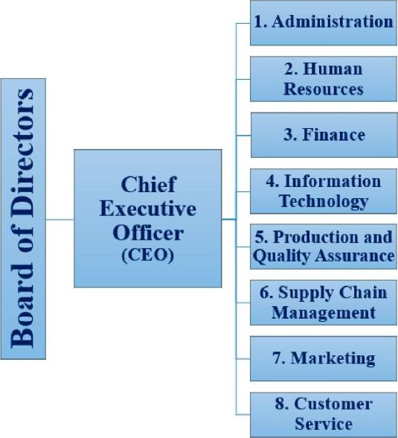

№4

Efficient communication at the workplace is one of the signs of a high performance culture. Exchanging

information and ideas within an power

organisation is called workplace communication. In every aspect of life (both professional and personal), effective communication is important to success and happiness. Effective communication at the workplace is central to all business goals.

Improving communication starts at the top to meet your business intent. Communication at the workplace defines organisational goals and helps co-workers to collaborate.

What are effective communication strategies?

- Start using the right tools for your business. Fortunately, tools like ProofHub, Slack, Zoom can help you to boost company communication providing a total seamless communication experience.

- Encourage two-way communication. Encourage your employees to ask questions or voice their opinions helping them feel empowered.

- Tell people what they are doing right. It is a good idea to tell people about their good things on a daily basis.

- Specific and descriptive feedback. Give feedback that is concrete. Give directions to the person exactly on what they are doing well and what needs to be improved.

- Schedule a compulsory check-in. Organising a short quick call with a very specific agenda brings in a lot of advantages.

- Organise engaging team building activities.Team building activities enhance productivity and engagement.

What are the benefits of effective communication at the workplace?

Effective communication grants:

- less misunderstanding;

- healthy workplace culture,

- easy conflicts solving;

- team spirit;

- stronger teamwork;

- self-esteem increasing;

- clear directions;

- higher employee job satisfaction;

- business success.

Communication can be formal, informal, internal or external. And within an organisation, it is important to develop a healthy and beneficial communication process. Effective communication is the key to achieving long-term success, so make sure you follow the above outline strategies. No matter what stage you are at the workplace, you need to communicate ideas well.

**Тема 3 урок 3**

* + variety ofjobs in the sphere of information technology;
  + personal qualities of any IT specialist;
  + typical responsibilities and skills for different IT department jobs;

-future skills for IT specialists and their importance.

Information technology (IT) is a specific sector that is responsible for the building of computer systems and the management of computer networks. IT continues to change the way we live, play, and do business, so it should come as no surprise that IT is the fastest growing career fìeld, and will continue to before years to come. There are some core areas of it :web developer, computer operator, IT manager, database administrator, programmer, robotics engineer, system analyst, help desk technician, security specialist, hardware engineer and game developer.

A good specialist has not only good hard skills, but also personal qualities. In my opinion, there are several personal qualities that any IT specialist should have. First of all, such a specialist must be responsible. The person must clearly set the time frame in which he needs to complete the task. The specialist also needs to be confident. Such people can set aside their position and argue why he did this and not otherwise. And at the end I would like to say about self-motivation. A person who has motivation works harder, because he has a goal.

To stay competitive in our careers, we must not only do our jobs well today, but be prepared for how we'll be doing our jobs well in two, five, ten years from now. So, what skills and experience will be most important in the future?

- Emotional intelligence. Most people can pass a certification exam or learn a new software application. But not everyone has an ability to lead a team through a tough project, build relationships with stakeholders, or keep a remote team engaged. Employees should place more emphasis on being able to deal with conflicts, manage a virtual team and deliver on strategy to achieve tangible benefits for the business. We can call them soft skills or emotional intelligence — employers are going to seek out this attribute more and more.

- Adaptability. Because of technological advances, shifts in society, and the many unknowns of the future, project managers need to be open to new ideas, flexible to pivot with changing times, and ready to adapt to changes.

- Working with and managing remote teams. Working remotely and with dispersed, international teams is on the rise, and employers will be looking for IT specialists who have experience successfully working from home, as well as managing a remote team.

Hiring managers at remote companies are looking for candidates who can communicate verbally and in writing, have an independent streak, and have a track record of successfully managing their own projects.

- Data science expertise. The Internet of things, automation, and artificial intelligence have been the buzzwords since 2017. These advances are going to shake up every industry in some way. IT management is definitely getting a pass on this one.

For IT professionals, this means that our programs, systems are going to staff talking to you. They'll help you to identify risks, detect problems, and unload the administrative tasks through automation. So, there will be an increased need for project managers with big data expertise.

**Тема 3 урок 4**

* + personal vs professional vs continuous professional development;

- elements of CPD;

* + motivation as a key factor for professional development;

- training and its forms; - the benefits of CPD.

Motivation is a key factor contributing to people 's professional development. According to humanist psychologist Abraham Maslow, our actions are motivated in order to achieve certain needs. Maslow first introduced his concept of a hierarchy of needs in his 1943 paper "A Theory of Human Motivation " and his subsequent book "Motivation and Personality ". This hierarchy suggests that people are motivated to fulfill basic needs before moving on to other, more advanced needs. This hierarchy includes psychological needs, safety, love, esteem and in the end self actualization.

The aim of personal and professional development is to help you to manage your own learning and growth throughout your career.

Professional development can increase your confidence and credibility; improve efficiency; develop your ability to influence and lead; enable networking; keep your knowledge and skills current; help you to achieve career goals; enable you to become a better employee. Professional development is something to be valued, cherished and actively pursued. It is proven to enable career development and progression, allowing you to excel and shine within your current role and as you progress.

Continuing Professional Development (CPD) is a process of building, maintaining and enhancing your knowledge and skills. CPD helps you to plan your development, review what you have learnt and evaluate the effectiveness of your activity. Your commitment to CPD is important as the activities you choose will help to underpin your validity and competence as a professional.

The Chartered Institute of Personnel and Development (CIPD) describes professional development in this way: "Continuing Professional Development (CPD) is a combination of approaches, ideas and techniques that will help you to manage your own learning and growth. Thefocus ofCPD isfirmly on results — the benefits that professional development can bring you in the real world. Perhaps the most important message is that one size doesn 't fit all. Wherever you are in your career now and whatever you want to achieve, your CPD should be exactly that: yours. '

CPD is not always formal and linear; activities can range from formal educational activities such as instructor-led training courses, workshops or seminars to more informal approaches such as work-based learning or mentoring. CPD can also include self-directed study such as e-learning courses and structured reading. It's a record of what you experience, learn and then apply.

CPD helps to ensure you have the knowledge and skills necessary to succeed as a professional. It helps you to build professional confidence and, in turn, the reputation of the profession; adapt positively to change by continuously updating skills support any career goals by focusing on relevant training and development; be more productive and efficient by reflecting on your learning and highlighting gaps in your knowledge and experience and planning action accordingly.

Any professional must take ownership of their career and development. The Continuous Professional Development Cycle includes the following steps: identifying your development needs through planning and then carrying out your learning activities, reflecting on your learning and then applying it and sharing it with others. It can also be as simple as asking yourself these three questions:

1. Where am I now?
2. Where do I want to be?
3. How am I going to get there?

Professional development is something that can, and Invariably does, happen In a variety of ways. Professional development isn't always a linear activity. In fact, almost 80 % of your development will be completed in the workplace by undertaking activities that might include special projects, secondments or activities that are new to you.

Training is teaching, or developing in oneself or others, any skills and knowledge that relate to specific useful competencies. Training has specific goals of improving one's capability, capacity, productivity, and performance. In business, training is the investment of resources in the employees of a company, so they are better equipped to perform their job. The types of resources invested may include time and money to develop, implement, and evaluate training programmes.

The well-trained employee acquires an advantage for him- or herself. By participating in training, employees can deepen or expand their existing skill set and increase their understanding of the organisation. In addition, a well-trained employee may be able to take advantage of internal promotion opportunities and becomes more marketable if he or she leaves the company. Other potential benefits are as follows: increased job satisfaction and morale among employees; increased employee motivation; increased efficiencies in processes, resulting in financial gain; increased capacity to adopt new technologies and methods; increased innovation in strategies and products; reduced employee turnover; enhanced company image, e.g., building a reputation as a "great place to work". Training provides greater skill and knowledge to employees, which, actually, leads to better job performance.ч